Analog IC Design Implementation and Verification Academic Curriculum
Prerequisites:
- The academic institution must be a part of the Cadence Academic Network.
- The professors, lab assistants and students must have accounts on the Cadence Support site to access tool courses and lab data.
- The academic institution must have Cadence tools and licenses installed to run the labs.
After downloading the Analog_IC_Design_Implementation_and_Verification.zip file, unzip it.
The resulting directory contains the following directories and files:
- The README_Syllabus Usage. docx file (this file).
- An Excel Spreadsheet that provides a syllabus for a 16-week course.
Analog IC Design Implementation and Verification Syllabus.xlsx
- A Lectures and Labs folder which contains, for 16 weeks:
  - Main lectures in PDF (or PPTx) format
  - The following weeks have lectures as well as labs. There is also a database that you can download and untar. The database contains the design required to run the labs.
    - Week 1
    - Week 2
    - Week 3
  - The remainder of the weeks contain only lecture PDF files. Lectures for some weeks are combined in folders. This is done to ease transitions between related topics, decrease rigidity, and allow flexibility in teaching the content.
    - Weeks 3 and 4
    - Weeks 7 and 8
    - Weeks 12 and 13
    - Weeks 14 to 16
  - The folders mentioned above are appropriately named.
  - Snapshots below illustrate what the lecture folders look like in Windows Explorer.

Lectures and Labs folder
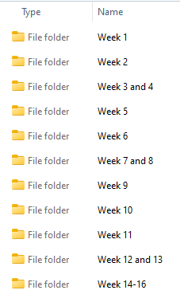
Expanding the Week 1 folder (Week 2, and the Week 3 and 4 will be similar):

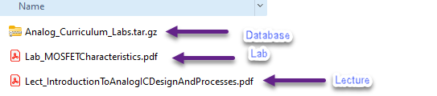

Expanding the Week 5 folder (remainder weeks will be similar)
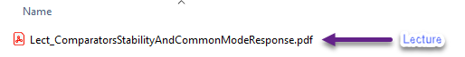

How to use the materials:
Firstly, view the file Analog IC Design Implementation and Verification Syllabus.xlsx
- The spreadsheet provides a weekly schedule of the lectures. The Lecture Topic and Lecture PDF Name and Content columns list the content for specific weeks.
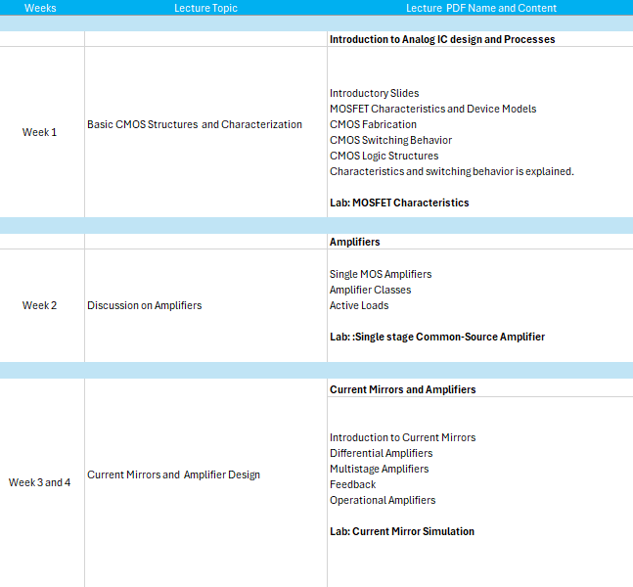

IMPORTANT: Again, Week 1, Week 2, and Week 3 have separate labs created to help the students get started on basic schematic setups and simulations.
These are different from those associated with Cadence's regular online course offerings. The lab documents and the database for these three weeks are downloadable through the folder and the online interface. The remaining weeks do not have separate lab documents. You should take the associated Cadence Online Course—details in the next section.

- The next three columns provide links to Cadence Online Courses. The specific material from these classes that enforces the lecture content is listed under the Cadence Course Lecture Modules column. We have identified specific Cadence Course Lab Modules to support the lectures.
Important: Once you log into the Cadence online course, you can download the lab instructions (PDF) and the databases (zip files)to run the labs. These PDFs and databases can be accessed from https://support.cadence.com and differ from the lecture-only PDF folder.
Week 9 does not have an associated Cadence online course. It is supported by a Rapid Adoption Kit (RAK), which is available from the online support portal.
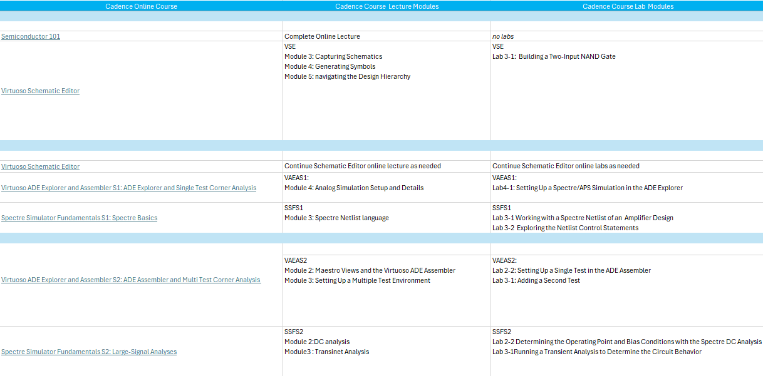

- As mentioned, each online course contains a Database Downloads section from where you can download the database for the labs and the PDF lab instructions. The Lecture PDFs of the courses are also downloadable.
The online courses have can have either of the interfaces listed below:
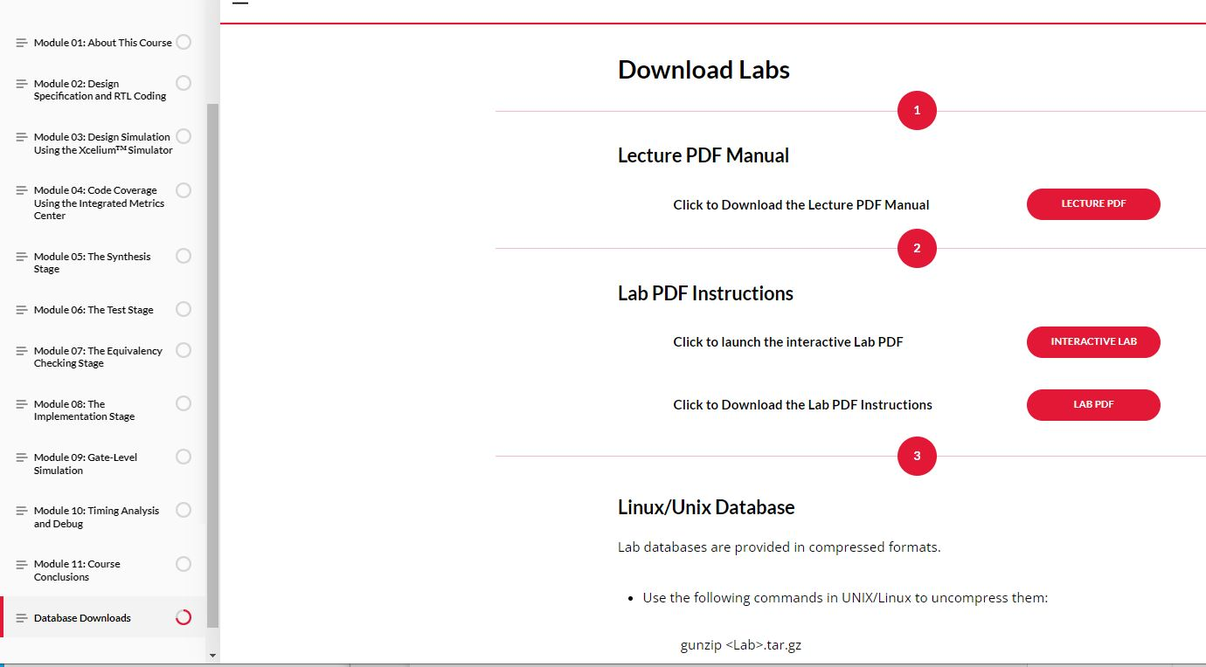
OR
